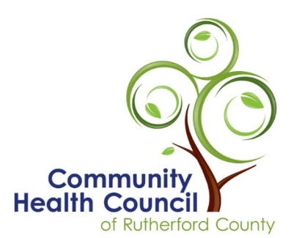
Health Matters Column
Contact: Jill Miracle, Community Health Council of Rutherford County
828-202-4630
Release after February 2, 2023
HealthCouncilRC@gmail.com

Free Skin Cancer Screenings

The Community Health Council will offer free skin screening appointments on Saturday, March 11, 2023 from 9:00 to noon at the Cancer Resource Center in Forest City. Please call 828-245-4596 to schedule a screening time. Insured and uninsured persons are welcomed at the event. Providers from several healthcare offices will provide the screenings.

Skin cancer is the fastest growing cancer in the United States. While some occupations and skin types may increase the risk, nobody is excluded.

The four types of skin cancer are squamous cell carcinoma, basal cell carcinoma, Merkel cell carcinoma and melanoma. Squamous cell carcinoma is typically seen on your face, neck, arms, scalp and the back of hands and ears because these areas are the most exposed to sun. A spot anywhere on the body that looks crusted or has scaly patches with a red bump, a tumor that has changed in size, or a sore that won’t seem to heal, may all be signs of squamous cell cancer. It is important to keep an eye on concerning spots that look like this description, because if not caught early, squamous cell cancer can often grow into deeper layers of skin, or rarely, into the lymph nodes.

Basal cell carcinoma is the most common type of skin cancer, and is also usually seen on your face, scalp, and ears. The best way to look for basal cell is by looking for small, dome-shaped bumps that are pearly white or pink. If you have a sore on the surface of your skin that repeatedly heals and then returns, this may also be a sign of basal cell carcinoma.

Merkel cell carcinoma is the most-rare skin cancer that happens on the top layer of your skin near your nerve endings. It is also usually found in high sun exposed areas like your head and neck, but can also be found on your arms, legs, and torso. When looking for this type of cancer, you should look for a red or purple bump on the skin that is painless but may turn into an ulcer or a sore.

Melanoma is rarer than the other skin cancers but is more dangerous because of how fast it can spread to other parts of your body. For men, it is usually found on your chest and back, but usually on the legs for women. The neck and face are also common places to find it for both men and women. Melanoma appears brown or black, but sometimes can be pink, tan, or white. It can be found in many other parts of your body, which is why it is important to look everywhere for it. A spot that is not symmetrical (half is different than its other half), has jagged edges, has an abnormal colors, is larger than the size of a pencil eraser, or changes in size, shape, or color should be looked at by a professional.

Early detection saves lives. Call today to leave your information regarding an appointment. Someone will call you back after March 1 to provide more information and to confirm your appointment time.

The Community Health Council of Rutherford County provides the structure for the leaders
of major organizations to work effectively together to address Rutherford County’s key health
concerns. Services like skin screenings are offered at no charge to Rutherford County residents through collaborative efforts of Council members.

