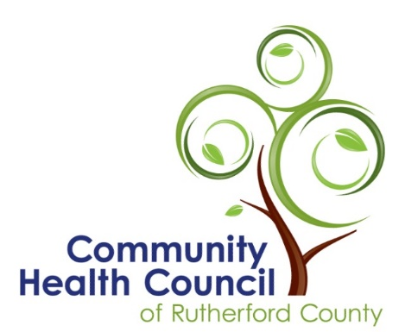

March 22, 2022
For Immediate Release
RE: Growing Together Community Garden Grants

Growing Together Rutherford
The Community Health Council of Rutherford County is offering grants to non-profit organizations who plan to start a community garden. The Council’s hope is to help organizations throughout the county begin a garden where neighbors will work together to construct the garden and grow food for their own consumption and share extra produce with those in need. Awards will be made to non-profit organizations, clubs, or churches. Each group will be expected to commit at least three years to the project.
The steering committee from the Rutherford County Food Council will review applications and choose up to five Growing Together Awards representing different areas in the county. Each winner will receive up to $1,500 for items such as supplies, plants, seeds, water sources, fencing, or tools needed to start the garden. Existing Growing Together gardens may apply for up to $500 to replenish or expand their current gardens.

Training for all aspects of gardening is available through the local extension office. The Health Council will communicate opportunities for garden leaders and volunteers to learn more about gardening throughout the season. Awardees will gather to talk about best practices and discuss the progress of their projects. Normal progress reports will be required by the grantees. As desired, the Health Council will connect growers to local food pantries to receive donations through established partnerships.
In a recent community health assessment, less than 7% of Rutherford County respondents reported that they eat the recommended daily servings of fresh foods. Unhealthy eating leads to poor health, including obesity, cancer, and chronic diseases such as diabetes, heart disease, and high blood pressure.
A food study conducted in 2019 established that access to healthy, local produce is restricted in Rutherford County. Many of the county’s rural communities are cited as food deserts, meaning that affordable, healthy food is limited or non-existent because grocery stores are too far away. Over 29% of residents in Rutherford County live more than 10 miles away from a full-service grocery store.
Jill Miracle, Executive Director of the Community Health Council, explains the Growing Together Rutherford project. “We want to support a new network of community gardeners because the consumption of fresh, healthy fruits and vegetables leads to improved health in people of all ages. The Community Health Council first developed the grant opportunity in 2018 to assist residents of the county to become intentional about increasing the number of servings of locally grown food in their diets. Providing grant funding for communities to experiment with growing and preparing different kinds of fresh foods is one strategy toward healthier eating.”
The grant application can be found in the NEWS section on the Community Health Council of Rutherford County website, http://www.healthcouncilrc.com and from posts on their Facebook page. The deadline for grant applications is 5:00 on April 15. Contestants will be notified about awards by April 22. For more information about the opportunity or to request a printed copy of the grant application, please call Jill Miracle at 828-202-4630 or email HealthCouncilRC@gmail.com.

The Community Health Council of Rutherford County is grateful to RHI Legacy Foundation for providing funding for the Growing Together project.

