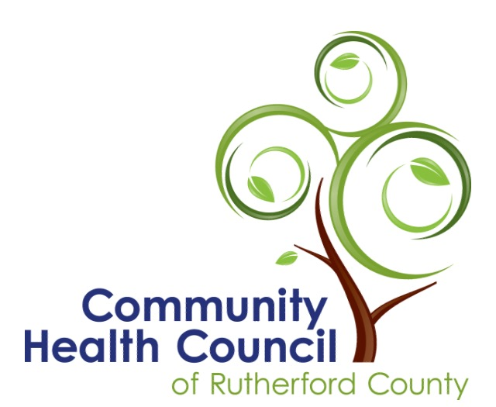

Health Matters
Contact Jill W. Miracle 828-202-4630 or HealthCouncilRC@gmail.com
March 8, 2021
Growing Together Rutherford
The Community Health Council of Rutherford County is promoting healthy eating across Rutherford County through a competition for grant funding to start community gardens. The Council’s hope is to help organizations throughout the county to begin a garden where neighbors will work together to construct the garden, and then grow and share the local produce. Awards will be made to non-profit organizations, clubs, or churches. Each group will be expected to commit at least three years to the project.

The steering committee from the Rutherford County Food Council will review applications and choose up to 5 winners representing different areas in the county. Each winner will be awarded up to $1,500 for items such as supplies, plants, seeds, water sources, fencing, or tools needed to start the garden. Existing Growing Together gardens may apply for us to $500 to replenish or expand their current gardens.

Training will be provided to the leaders and participants in the gardening project, including instructions about starting a summer and fall garden, preventing pests, using the produce once it is grown, and preparing the garden for winter. When it becomes safe, the awardees will gather to talk about best practices and discuss the progress of their projects. Normal progress reports will be required by the grantees.
In a recent community health assessment, less than 7% of Rutherford County respondents reported that they eat the recommended daily servings of fresh foods. Unhealthy eating leads to poor health, including obesity, cancer, and chronic diseases such as diabetes, heart disease, and high blood pressure.
A food study conducted in 2019 established that access to healthy, local produce is restricted in Rutherford County. Many of the county’s rural communities are cited as food deserts, meaning that affordable, healthy food is limited or non-existent because grocery stores are too far away. Over 29% of residents in Rutherford County live more than 10 miles away from a full-service grocery store.
Jill Miracle, Executive Director of the Community Health Council, explains the Growing Together Rutherford project. “We want to support a new network of community gardeners because the consumption of fresh, healthy fruits and vegetables leads to improved health in people of all ages. The Community Health Council developed the grant opportunity to assist residents of the county to become intentional about increasing the number of servings of locally grown food in their diets. Providing grant funding for communities to experiment with growing and preparing different kinds of fresh foods is one strategy toward improving healthy eating.”
The grant application can be found in the NEWS section on the Community Health Council of Rutherford County website, http://www.healthcouncilrc.com and from posts on their Facebook page. The deadline for grant applications is 5:00 on April 9. Contestants will be notified about awards by April 15. For more information about the opportunity or to request a printed copy of the grant application, please call Jill Miracle at 828-202-4630 or email HealthCouncilRC@gmail.com.

The Community Health Council of Rutherford County is grateful for funding for this project from RHI Legacy Foundation.

